SBA-10

Pooja R-211478

1. Write a Binary search program to search the elements of the integer Array.

**class** Binarysearch {

**int** binarySearch(**int** array[], **int** x, **int** low, **int** high) {

// Repeat until the pointers low and high meet each other

**while** (low <= high) {

**int** mid = low + (high - low) / 2;

**if** (array[mid] == x)

**return** mid;

**if** (array[mid] < x)

low = mid + 1;

**else**

high = mid - 1;

}

**return** -1;

}

**public** **static** **void** main(String args[]) {

Binarysearch ob = **new** Binarysearch();

**int** array[] = { 3, 4, 5, 6, 7, 8, 9 };

**int** n = array.length;

**int** x = 4;

**int** result = ob.binarySearch(array, x, 0, n - 1);

**if** (result == -1)

System.***out***.println("Not found");

**else**

System.***out***.println("Element found at index " + result);

}

}

**OUTPUT**

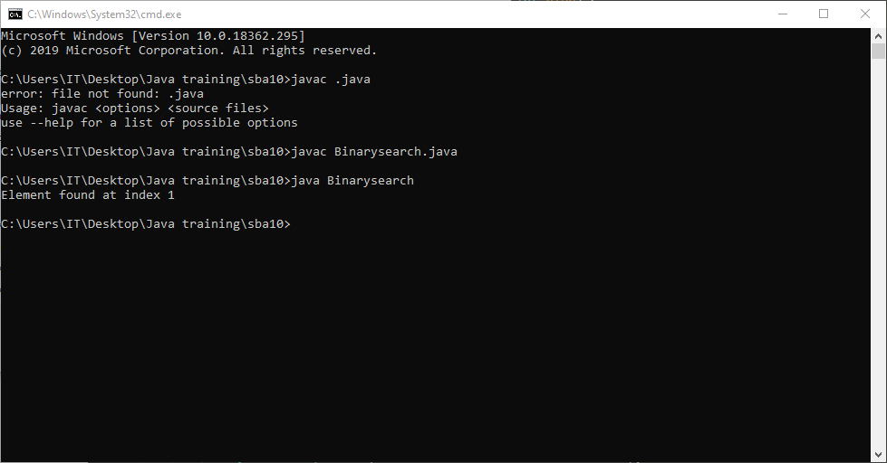

1. Create a login page using the Bootstrap and also include the Typescript and ES6 features like Loops, If-else conditions.

